Services:
• College Counseling & Admissions Strategy
• Rising Generation Leadership Development
• Parent Coaching & Family Advisory
• Writing & Narrative Development
• Career Exploration & Professional Readiness
• THRIVE College Integration & Young Adult Development
- 12 month

Challenge:
- Wechat

Sales events:
- KPI

Customer:
- 1 gen
- Chinese families

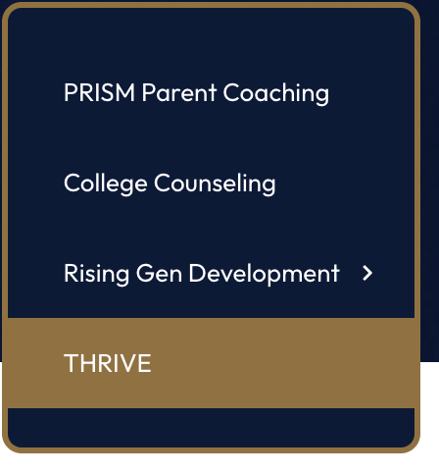

Business Positioning
- How do you differentiate Interface from firms like Crimson Education, InGenius Prep, IvyWise, Collegewise, and Empowerly?

- What percentage of revenue comes from admissions consulting versus leadership development and THRIVE?

Client Base
- Who is your ideal customer?
  - High-net-worth families?
  - International families?
  - U.S. domestic families?
  - Students targeting Top 20 universities?
- What type of family gets the most value from Interface?

Growth
- Where is the company investing most heavily over the next 2–3 years?

- Which services are growing fastest?

- What new opportunities are you seeing in the education market?

